

**Computer Networks**

**2nd Year, 2nd Semester**

**2018**

**Lab 2 - Introduction to Router Configurations**



** Follow the lab sheet and if you need any clarifications get assistance from a lab instructor.

**Activity 1 – Understanding Cisco IOS software**

* Cisco **IOS** stands for **Internetwork Operating System** provides a **Command Line Interface (CLI)** to configure various settings of the devices.

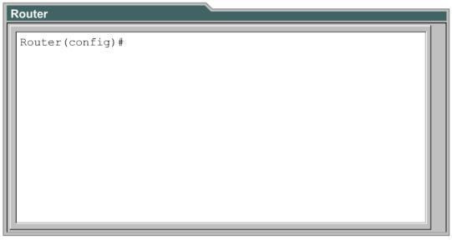

**Activity 2 – Understanding the modes of a router**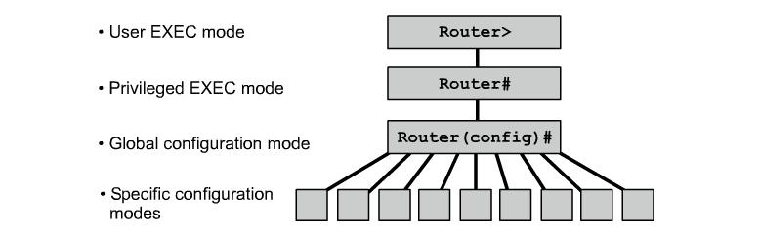

***Note:*** Notice how the prompt changes when you enter different modes.

* *User EXEC mode*

Mainly for checking router status.

* *Privileged EXEC mode*

To perform additional status monitoring and entering into configuration mode.

* *Global configuration mode*

To configure global configurations which will affect the router as a whole and to enter into specific configuration modes.

**Use the following commands to navigate between various modes,**

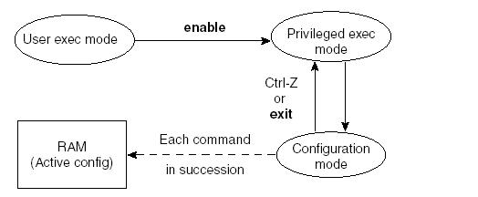

**Configure terminal**

**Activity 3 – Help command**

In IOS, help command is the **?** (question mark).

* You can issue this in any mode to view all the supported commands in that particular mode.

Router>**?**

Exec commands:

<1-99> Session number to resume

connect Open a terminal connection

disable Turn off privileged commands

disconnect Disconnect an existing network connection

enable Turn on privileged commands

exit Exit from the EXEC

logout Exit from the EXEC…

* You can also issue this as a way of finding the additional options of a command

E.g.

Router>**show ?**

***Important:*** Help command can be used as a powerful learning tool when configuring network devices.

**Activity 4 – Basic configurations with a router**

1. Changing the **hostname** of a router.
   1. Add a router to the packet tracer work space.
   2. Configure the *hostname* of the router to Malabe (Hint: You should be in global configuration mode and use the help command).

What is the command you used: …………………………………………………………………

1. Set a **password** for privileged mode.
   1. Configure the privilege mode **password** to malabe123

(Hint: You should be in global configuration mode and use the help command).

What is the command you used ……………………………………………………………………

1. Set a **secret** for privileged mode.
   1. Configure the privilege mode **secret** to malabe987

(Hint: You should be in global configuration mode and use the help command).

What is the command you used: …………………………………………………………………

What is difference between privilege mode password and secret?

………………………………………………………………………………………………………

In case both are configured, which will have the priority?

………………………………………………………………………………………………………

1. Set a **message-of-the-day banner** for the router.
   1. Configure **message-of-the-day banner** to !!!Authorized Personal Only!!!

(Hint: You should be in global configuration mode and use the help command).

What is the command you used: …………………………………………………………………

5. **Remove** the privilege mode **password** (Hint: use the **no** keyword).

What is the command you used: …………………………………………………………………

**Activity 5 – Verifying router status**

What is the difference between running-config and startup-config?

………………………………………………………………………………………………………

………………………………………………………………………………………………………

**Activity 6 – Saving running-config to startup-config**

1. What is the command to save the running-config to startup-config?

(Hint: You have to be in the privilege mode).

……………………………………………………………………………………………………

2. Why do you have to save the running-config to startup-config?

………………………………………………………………………………………………………

………………………………………………………………………………………………………

**Activity 7 - IP Address Configuration**

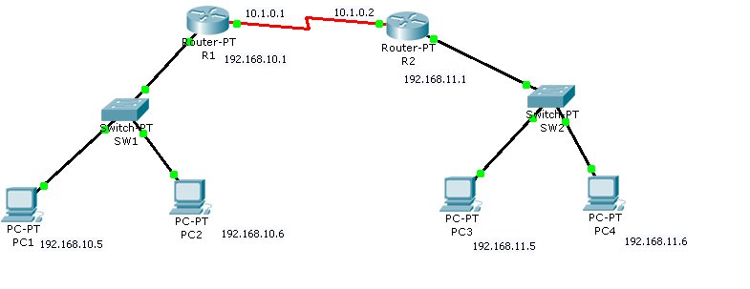

1. Design the above network in Packet Tracer Network Simulator.
2. Assign IP Addresses and subnet masks for the interfaces of the routers with the given IP Address plan.
3. Verify the connectivity within the LANs.
4. View the routing table with directly connected networks.

*Router#Show ip route*

1. Enable inter LAN communication by configuring Static routing.

*Router(config)#ip route <Destination network address> <Destination network subnetmask> <exit interface name | next hop ip address>*

1. Analyze the entries of the routing table again.
2. Verify the inter LAN communication.